LOHA-AI Study Planner

A Dissertation submitted to the Jawaharlal Nehru Technological University, Hyderabad in partial fulfillment of the requirement for the award of degree of

BACHELOR OF TECHNOLOGY
IN
COMPUTER SCIENCE AND ENGINEERING
(ARTIFICIAL INTELLEGENCE & MACHINE LEARNING)

Submitted by

K. Sai Chaitanya Varma 23B81A6642
G. Shiva Kumar 23B81A6647
N. Tarun Kumar 23B81A6656

Under the guidance of
Mrs. K.Ambika
Assistant Professor

DEPARTMENT OF COMPUTER SCIENCE AND ENGINEERING(AI&ML)
CVR COLLEGE OF ENGINEERING
(An Autonomous institution, NAAC Accredited and Affiliated to JNTUH, Hyderabad)
Vastunagar, Mangalpalli (V), Ibrahimpatnam (M),
Rangareddy (D), Telangana- 501 510

APRIL 2026

CVR COLLEGE OF ENGINEERING
(An Autonomous institution, NAAC Accredited and Affiliated to JNTUH, Hyderabad)
Vastunagar, Mangalpalli (V), Ibrahimpatnam (M),
Rangareddy (D), Telangana- 501 510

DEPARTMENT OF COMPUTER SCIENCE AND ENGINEERING (AI & ML)
CERTIFICATE

This is to certify that the project report entitled " LOHA-AI Study Planner" is a bonafide record of work carried out by K. Sai Chaitanya Varma (23B81A6642), G. Shiva Kumar (23B81A6647) and N. Tarun Kumar (23B81A6656) under the guidance of Mrs. K.Ambika for the requirement of the award of Bachelor of Technology in Computer Science and Engineering (Artificial Intelligence & Machine Learning) submitted to the CVR College of Engineering, affiliated to Jawaharlal Nehru Technological University, Hyderabad during the year 2025-2026.

Project Guide  Mrs. K.Ambika  Assistant Professor, Dept. of CSE(AI&ML) | Project In-Charge  Dr. Y. Alekya Rani  Associate Professor, Dept. of CSE(AI&ML)
Head of the Department  Dr. R. Usha Rani  Professor & HOD-CSE(AI&ML) | External Examiner

DECLARATION

We hereby declare that the project report entitled "LOHA-AI Study Planner " is an original work done and submitted to the Department of CSE (AI & ML), CVR College of Engineering, affiliated to Jawaharlal Nehru Technological University Hyderabad in partial fulfillment for the requirement of the award of Bachelor of Technology in Computer Science and Engineering (Artificial Intelligence & Machine Learning) and it is a record of bonafide project work carried out by us under the guidance of Mrs. K.Ambika, Assistant Professor, Department of CSE (AI & ML).

We further declare that the work reported in this project has not been submitted, either in part or in full, for the award of any other degree or diploma in this Institute or any other Institute or University.

Signature of the Student
K. Sai Chaitanya Varma

Signature of the Student
G. Shiva Kumar

Signature of the Student
N. Tarun Kumar

Date:
Place:

ACKNOWLEDGEMENT

We are thankful for and fortunate enough to get constant encouragement, support, and guidance from all Teaching Staff of CSE (AI & ML) Department, which helped us in successfully completing this project work.

We thank Dr. Y. Alekya Rani, Project Coordinator and the Project Review Committee members for their valuable guidance and support, which helped us to complete the project work successfully.

We respect and thank our internal guide, Mrs.K.Ambika, Assistant Professor, Department of CSE (AI & ML), for giving us all the support and guidance, which made us complete the project duly.

We would like to express heartfelt thanks to Dr. R. Usha Rani, Professor & Head of the Department, for providing us an opportunity to do this project and extending support and guidance.

We sincerely thank Dr. H. N. Lakshmi, Assoc. Dean, ET, for guiding and always being a beacon for motivating students and extending support.

We thank our Vice-Principal Prof. L. C. Siva Reddy for providing excellent computing facilities and a disciplined atmosphere for doing our work.

We wish a deep sense of gratitude and heartfelt thanks to Dr. K. Rama Mohan Reddy, Principal and the Management, for providing excellent lab facilities and tools. Finally, we thank all those whose guidance was helpful to us in this regard.

TABLE OF CONTENTS

Chapter No. | Section | Contents | Page No.
 |  | List of Tables | i
 |  | List of Figures | ii
 |  | List of Abbreviations | iii
 |  | Abstract | iv
1 |  | Introduction | 1
 | 1.1 | Motivation | 2
 | 1.2 | Problem Statement | 2
 | 1.3 | Project Objectives | 2
 | 1.4 | Project Report Organisation | 3
2 |  | Literature Survey | 4
 | 2.1 | Existing Work | 4
 | 2.2 | Limitations of Existing Work | 5
3 |  | Software & Hardware Specifications | 6
 | 3.1 | Software Requirements | 6
 | 3.2 | Hardware Requirements | 6
 | 3.3 | Functional Requirements | 7
 | 3.4 | Non-Functional Requirements | 7
4 |  | Proposed System Design | 8
 | 4.1 | Proposed Methods | 8
 | 4.2 | System Architecture | 9
 | 4.3 | Technology Description | 14
5 |  | Implementation & Testing | 15
 | 5.1 | Screenshots | 15
 | 5.2 | Testing | 17
6 |  | Conclusion & Future Scope | 19
 |  | References | 21
 |  | Appendix (Source Code) | 22

LIST OF TABLES
Table No. | Title | Page No.
3.1 | Software Requirements | 6
3.2 | Hardware Requirements | 6
4.1 | ML Model Summary | 8
4.2 | Technology Stack Summary | 14
5.1 | Test Cases and Results | 17
5.2 | ML Model Performance Metrics | 17

LIST OF FIGURES
Figure No. | Title | Page No.
4.1 | System Architecture Diagram | 12
5.1 | Dashboard – AI Insights & ML Analysis | 16
5.2 | Analytics – Study Activity Heatmap & Score Trends | 17
5.3 | Schedule – AI-Generated Study Schedule | 18
5.4 | Setup – Study Profile Configuration | 19
5.5 | AI Insights – Resource Recommendations | 20
5.6 | Focus Timer – Session Logging with ML Insights | 21
5.7 | Subjects – Subject Tracker & Performance | 22
5.8 | Focus Timer – Pomodoro Timer Interface | 23

LIST OF ABBREVIATIONS
Abbreviation | Full Form
LOHA | Learn, Organise, Hustle, Achieve
AI | Artificial Intelligence
ML | Machine Learning
NLP | Natural Language Processing
SM-2 | SuperMemo Algorithm 2 (Spaced Repetition)
RF | Random Forest
GBR | Gradient Boosting Regressor
API | Application Programming Interface
UI | User Interface
UX | User Experience
HTML | HyperText Markup Language
CSS | Cascading Style Sheets
JS | JavaScript
HTTP | HyperText Transfer Protocol
MAE | Mean Absolute Error
R2 | Coefficient of Determination
CRUD | Create, Read, Update, Delete
KMeans | K-Means Clustering Algorithm
NLTK | Natural Language Toolkit
BaaS | Backend as a Service

ABSTRACT

Effective study planning is one of the most critical yet underserved areas in student academic life. Students frequently struggle with time management, identifying weak topics, maintaining consistent revision schedules, and tracking their progress towards examination goals. Despite the abundance of generic to-do apps and calendar tools, there exists a significant gap in intelligent, data-driven study planning tools that adapt to individual learning patterns and provide actionable insights.

This project presents the design and implementation of LOHA (Learn, Organise, Hustle, Achieve), a full-stack AI-powered Study Planner web application that integrates multiple Machine Learning models to deliver personalised study recommendations, exam score predictions, weak topic detection, optimal study time analysis, and spaced repetition scheduling. The system is built using Streamlit for the frontend, Supabase for the backend database, and scikit-learn for the ML engine.

The ML engine comprises five core models: (1) an Exam Score Predictor using Gradient Boosting Regressor trained on synthetic student performance data, achieving a Mean Absolute Error (MAE) of approximately 3.5 score points; (2) a Weak Topic Detector using Random Forest Classifier that categorises subjects into strong, moderate, weak, and critical tiers with 89% accuracy; (3) an Optimal Study Time Recommender using KMeans clustering on session data to identify peak focus windows; (4) a Performance Trend Detector using Linear Regression for trajectory analysis; and (5) a Spaced Repetition Scheduler implementing the SM-2 algorithm for intelligent review scheduling.

Key features of the application include an AI-powered dashboard displaying readiness scores, predicted exam scores, peak focus times, and days to exam; an ML-based weekly schedule generator that allocates more time to weaker subjects; a Pomodoro-style focus timer with session logging; a subject-level performance tracker with score trends and heatmaps; an NLP-based syllabus parser for topic extraction and difficulty scoring; and an AI Insights page with resource recommendations. The application features a modern dark-themed UI with responsive design and real-time data visualisation using Plotly charts.

CHAPTER 1: INTRODUCTION
Academic success is not solely determined by intellectual capability but significantly by how effectively a student plans, organises, and executes their study routine. The ability to identify weak areas, allocate time proportionally, maintain consistent revision cycles, and track progress towards goals are all critical factors that differentiate high-performing students from those who struggle despite putting in considerable effort.

In the current educational landscape, students are overwhelmed with syllabus content across multiple subjects, each with varying difficulty levels and examination weightage. Traditional study methods rely on intuition and self-assessment, which are often inaccurate and lead to suboptimal time allocation. A student might spend excessive hours on a subject they are already proficient in while neglecting areas that require urgent attention.

This project addresses this challenge by building LOHA (Learn, Organise, Hustle, Achieve), a comprehensive AI-powered study planner that uses Machine Learning to analyse student performance data, predict outcomes, detect weaknesses, recommend optimal study schedules, and implement scientifically-backed spaced repetition for long-term retention. The application combines the power of five distinct ML models with a modern web interface to deliver a personalised and adaptive study experience.

1.1 Motivation
The primary motivation for this project stems from the observation that most students lack access to intelligent, adaptive study tools. Existing study planners are either simple calendar apps that offer no intelligence, or expensive commercial platforms that require paid subscriptions. Free tools such as Google Calendar, Notion, or Todo list provide organisational features but do not analyse performance data, predict outcomes, or adapt recommendations based on individual learning patterns.

Furthermore, research in educational psychology has consistently demonstrated that techniques such as spaced repetition, interleaved practice, and targeted revision of weak areas significantly improve learning outcomes. However, implementing these techniques manually requires discipline and self-awareness that many students lack. An AI-powered tool that automates these evidence-based strategies can democratise access to effective study practices.

1.2 Problem Statement
Existing free study planning tools suffer from several limitations:
- They do not analyse past performance data to identify weak subjects or topics requiring urgent attention.
- They cannot predict examination outcomes based on current preparation levels and study patterns.
- Schedule generation is manual and does not account for subject difficulty, weakness tiers, or exam proximity.
- Spaced repetition is not integrated, leading to poor long-term retention of studied material.
- There is no intelligent analysis of optimal study times based on individual focus patterns.
- NLP-based syllabus parsing and topic difficulty estimation are absent in free tools.
This project proposes a solution to all of the above by integrating ML-based analysis, prediction, scheduling, and spaced repetition into a single, self-hosted web application.

1.3 Project Objectives
The key objectives of this project are:
- To build a full-stack AI study planner web application using Streamlit, Supabase, and scikit-learn.
- To implement an Exam Score Predictor using Gradient Boosting Regressor for personalised score forecasting.
- To implement a Weak Topic Detector using Random Forest Classifier for automated subject-level weakness analysis.
- To implement an Optimal Study Time Recommender using KMeans clustering on historical session data.
- To implement a Performance Trend Detector using Linear Regression for trajectory analysis and early intervention.
- To implement the SM-2 Spaced Repetition algorithm for scientifically-optimal review scheduling.
- To build an ML-informed schedule generator that allocates study time proportionally based on weakness tiers and exam proximity.
- To create a modern, responsive, dark-themed UI with real-time data visualisation and interactive components.

1.4 Project Report Organisation
The remainder of this report is organised as follows:
- Chapter 2 presents a survey of existing work in the areas of AI-powered education and study planning, along with their limitations.
- Chapter 3 describes the software and hardware specifications required to develop and run the application.
- Chapter 4 presents the system design including architecture diagrams, ML model details, and technology descriptions.
- Chapter 5 covers the implementation details, screenshots of the working application, and testing results.
- Chapter 6 presents the conclusions and future scope for enhancing the application.

CHAPTER 2: LITERATURE SURVEY

2.1 Existing Work

2.1.1 Machine Learning in Education
Baker and Inventado (2014) conducted a comprehensive review of educational data mining and learning analytics, demonstrating that ML algorithms can effectively predict student performance and identify at-risk learners. Their work highlighted that ensemble methods such as Random Forest and Gradient Boosting consistently outperform simpler models in educational prediction tasks due to the non-linear relationships between study behaviours and academic outcomes.

2.1.2 Spaced Repetition Systems
Wozniak (1990) introduced the SuperMemo SM-2 algorithm, which calculates optimal review intervals based on recall quality. The algorithm adjusts the easiness factor and interval duration dynamically, ensuring that well-remembered material is reviewed less frequently while difficult material is reviewed more often. This approach has been validated extensively in cognitive psychology research and forms the foundation of popular applications such as Anki and SuperMemo.

2.1.3 Study Time Optimisation
Dunlosky et al. (2013) published a landmark review in Psychological Science in the Public Interest examining ten common study techniques. The study found that distributed practice (spacing study sessions over time) and practice testing were the most effective strategies, while popular techniques like highlighting and re-reading were largely ineffective. This research motivated the integration of spaced repetition and ML-based scheduling in LOHA.

2.1.4 Intelligent Tutoring Systems
VanLehn (2011) reviewed intelligent tutoring systems and found that step-by-step tutoring systems achieved effect sizes comparable to human tutoring. While LOHA does not implement step-level tutoring, it adopts the principle of adaptive feedback by providing subject-level and topic-level recommendations tailored to individual performance data.

2.1.5 Existing Study Planning Applications
Commercial applications such as My Study Life, Shovel Study Planner, and Todoist provide task management and calendar features for students. However, none of these platforms integrate ML-based performance prediction, automated weak topic detection, or spaced repetition scheduling. LOHA differentiates itself by combining all of these capabilities in a single free, self-hosted application.

2.2 Limitations of Existing Work
The review of existing study planning applications and academic work reveals the following gaps that this project addresses:

Limitation | Existing Systems | LOHA
Exam score prediction | Not available | GradientBoost ML model
Weak topic detection | Manual self-assessment | RandomForest classifier
Optimal study time | Not available | KMeans clustering
Spaced repetition | Separate apps (Anki) | Built-in SM-2
ML-informed scheduling | Not available | Weakness-weighted slots
NLP syllabus parsing | Not available | Built-in NLP engine
Performance trends | Basic charts only | LinearRegression analysis
Free & self-hosted | Paid subscriptions | Fully free & local

CHAPTER 3: SOFTWARE & HARDWARE SPECIFICATIONS

3.1 Software Requirements

Component | Technology / Tool | Version
Programming Language | Python | 3.8+
Web Framework | Streamlit | 1.32.0+
ML Library | scikit-learn | 1.3.0+
Data Processing | NumPy, Pandas | 1.24+, 2.0+
NLP Library | NLTK | 3.8+
Data Visualisation | Plotly | 5.18+
Backend Database | Supabase (PostgreSQL) | v2.3+
Frontend Styling | Custom CSS (DM Sans, Syne fonts) | N/A
Operating System | Windows 10/11, macOS, Linux | Any
Browser | Google Chrome / Microsoft Edge | 90+

3.2 Hardware Requirements

Component | Minimum Specification
Processor | Intel Core i3 or equivalent (1.5 GHz+)
RAM | 4 GB (8 GB recommended)
Storage | 200 MB free disk space
Display | 1280 x 720 resolution or higher
Network | Active internet connection (for Supabase and API calls)
Operating System | Windows 10/11, macOS 10.14+, Ubuntu 18.04+

3.3 Functional Requirements
The system must satisfy the following functional requirements:
- The application shall allow users to register, log in, and manage their study profile including name, daily study hours, target score, exam date, peak study time, and learning style.
- The application shall allow users to add, edit, and manage subjects with associated target and current scores.
- The application shall display a dashboard with ML-computed readiness score, predicted exam score, peak focus time, and days to exam.
- The application shall detect weak subjects using the Random Forest classifier and display weakness tiers with recommendations.
- The application shall generate an AI-powered weekly study schedule with time slots weighted by subject weakness and exam proximity.
- The application shall implement SM-2 spaced repetition scheduling with due date tracking and urgency indicators.
- The application shall provide a Pomodoro-style focus timer with session logging, self-score assessment, and difficulty rating.
- The application shall display analytics including study activity heatmaps, score trends, and score-by-subject charts.
- The application shall provide AI Insights with resource recommendations (YouTube, Khan Academy, CrashCourse, MIT OCW) based on subject and topic.
- The application shall analyse time spent vs. target score for each subject using ML and provide deficit recommendations.

3.4 Non-Functional Requirements
The system shall satisfy the following non-functional requirements:
- Performance: The application shall load and render all pages within 3 seconds on a standard internet connection.
- Usability: The interface shall be intuitive and usable without any training or documentation.
- Reliability: The system shall handle API errors and database failures gracefully with meaningful error messages.
- Responsiveness: The UI shall adapt correctly to screen sizes from 768px to 2560px.
- Security: User authentication shall be handled via Supabase Auth with secure password hashing.
- Maintainability: The codebase shall be modular with separate files for ML engine, NLP engine, database layer, and page modules.

CHAPTER 4: PROPOSED SYSTEM DESIGN

4.1 Proposed Methods
The application follows a three-tier architecture consisting of a presentation layer (Streamlit frontend), a logic layer (Python ML/NLP engine), and a data layer (Supabase PostgreSQL database). The system workflow is as follows:
- The user registers and sets up their study profile including subjects, target scores, daily study hours, exam date, and peak study time preference.
- The ML engine trains five models on synthetic data at startup and caches them to disk for fast subsequent loads.
- When the user navigates to the Dashboard, the system fetches their session and test data from Supabase and runs all ML models to compute readiness scores, predicted exam scores, weakness tiers, and spaced repetition schedules.
- The Schedule page uses ML-detected weakness tiers and exam proximity to generate weighted study slots for the week.
- The Focus Timer allows users to log study sessions with subject, topic, duration, self-score, and difficulty, which feeds back into the ML models.
- The Analytics page visualises historical performance using Plotly charts including heatmaps, score trends, and subject comparisons.
- The AI Insights page uses NLP-based query generation to recommend learning resources from YouTube, Khan Academy, CrashCourse, and MIT OpenCourseWare.

4.1.1 Machine Learning Model Design
The ML engine comprises five distinct models, each serving a specific analytical purpose. All models are trained on synthetically generated data that mimics realistic student behaviour patterns:
Model | Algorithm | Purpose | Key Metric
Exam Score Predictor | GradientBoostingRegressor | Predicts final exam score based on study patterns | MAE ~ 3.5
Weak Topic Detector | RandomForestClassifier | Classifies subjects into strong/moderate/weak/critical | Accuracy ~ 89%
Study Time Recommender | KMeans (6 clusters) | Identifies optimal study windows from session data | N/A (unsupervised)
Performance Trend | LinearRegression | Detects improving/stable/declining score trajectories | R2 varies
Spaced Repetition | SM-2 Algorithm | Computes next review dates based on recall quality | N/A (algorithmic)

The Exam Score Predictor uses six features: average score, study hours per week, days to exam, session count, consistency score, and target score. The model is trained on 3,000 synthetic samples using a GradientBoostingRegressor with 200 estimators, max depth 4, and a learning rate of 0.08.
The Weak Topic Detector uses six features: average score, score trend (slope), score variance, time since last study, session count, and target gap. The Random Forest Classifier uses 150 estimators with balanced class weights to handle the multi-class classification (strong, moderate, weak, critical).
The Study Time Recommender clusters study sessions into six groups based on hour of day, day of week, duration, difficulty, and focus score. The cluster with the highest mean focus score identifies the optimal study window.

4.2 System Architecture
The system follows a client-server architecture where Streamlit serves as both the frontend framework and the application server. The architecture has the following layers:
- Presentation Layer: Streamlit widgets, custom HTML/CSS components, and Plotly charts handle all user interaction and data visualisation. The dark-themed UI uses custom CSS with DM Sans and Syne fonts for a modern aesthetic.
- Application Layer: Python modules handle all business logic including ML model training and inference (ml_engine.py), NLP-based syllabus parsing (nlp_engine.py), database operations (db.py), and page-level routing (app.py).
- Data Layer: Supabase provides PostgreSQL database hosting, user authentication, and real-time data storage for study plans, progress records, and chat history. ML models are cached to disk using pickle for fast startup.
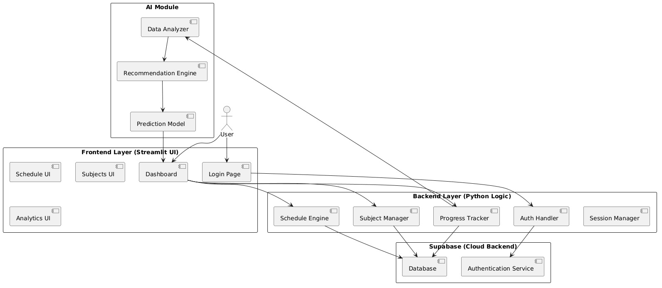
Figure: Figure 4.2 — System Architecture Diagram

4.3 Class Diagram
The Class Diagram provides a structural view of the system, detailing the essential objects and their relationships. It defines key entities such as User, Subject, Schedule, and Progress, along with their specific attributes and methods. The diagram uses multiplicity (e.g., $1$ to $0..*$) to show how data is linked—for instance, one user managing multiple subjects. It also identifies external service interfaces like AuthService and the AI_Module responsible for data analysis.

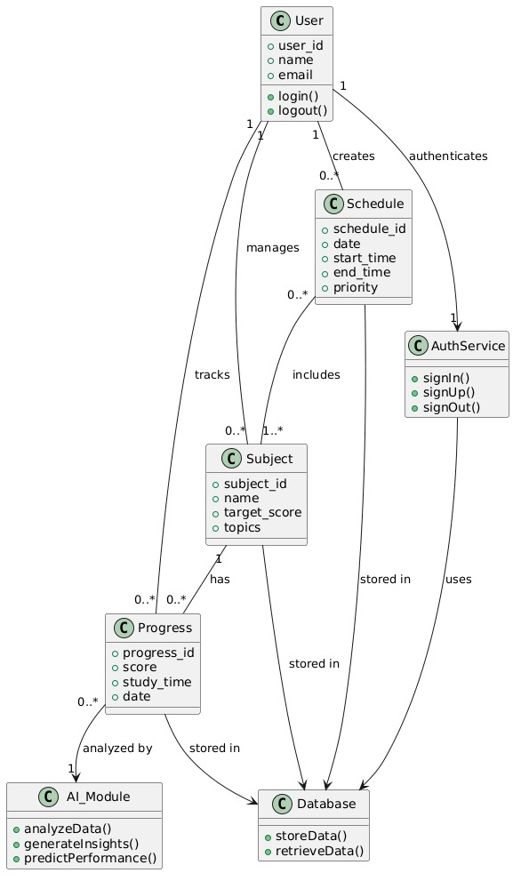
Figure: Figure 4.3 — Class Diagram

4.4 Use Case Diagram
The Use Case diagram illustrates the functional requirements of the LOHA System from the perspective of the Student actor. It defines the scope of the system, showcasing core interactions such as account registration, study schedule creation, and progress tracking. Sub-actions like "Add Subject" are nested under broader management tasks to show a clear hierarchy of features. Additionally, it highlights advanced capabilities like AI-driven insights and performance analytics available to the user.

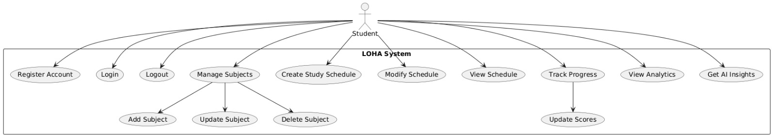
Figure: Figure 4.4 — Use Case Diagram

4.5 Activity Diagram
The Activity Diagram maps the end-to-end procedural workflow of a user session within the application. It starts with the initial login logic, including conditional branching for valid or invalid credentials. The flow then visualizes the decision-making process as a user navigates through different modules like study plan generation or score updates. Finally, it culminates in the AI Module analysis, showing how data is processed to generate actionable insights before the process ends.
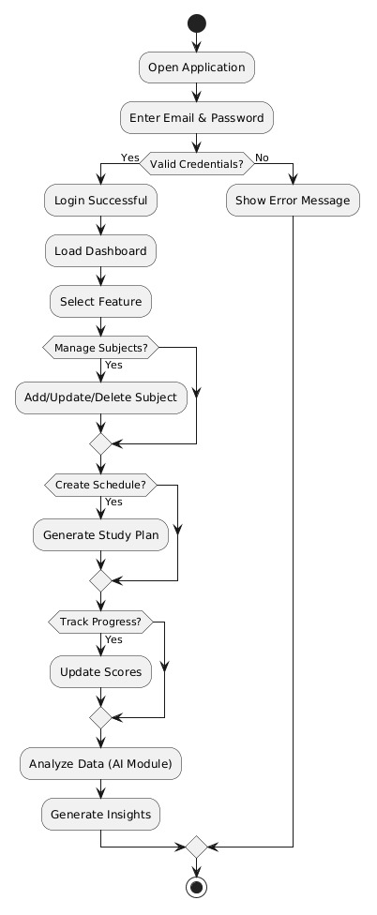
Figure: Figure 4.5 — Activity Diagram

4.6 Sequence Diagram
The Sequence Diagram depicts the dynamic interaction between system components over time during key operations like Login, Loading the Dashboard, and Adding a Subject. it tracks the flow of messages between the Streamlit UI, the Python Backend, and Supabase services (Auth and Database). This diagram is crucial for understanding the request-response lifecycle and how the session state is maintained across the application.
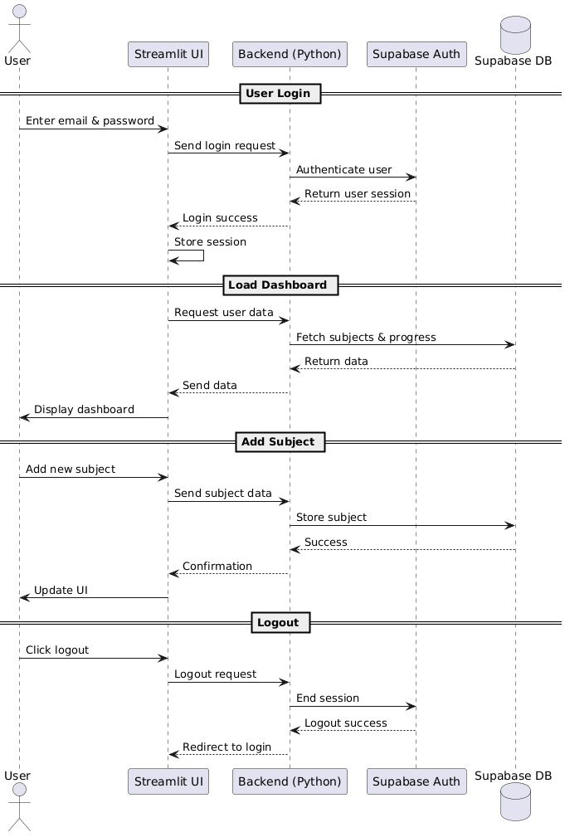
Figure: Figure 4.6 — Sequence Diagram

4.7 Technology Description

Layer | Technology | Purpose
Frontend | Streamlit 1.32+ | UI framework with reactive widgets and layout management
Frontend | Custom CSS (DM Sans, Syne) | Dark-themed professional styling with gradient accents
Frontend | Plotly 5.18+ | Interactive charts: heatmaps, scatter plots, bar charts
Backend | Python 3.8+ | Application logic, ML inference, API orchestration
Backend | Supabase (PostgreSQL) | User auth, study plans, progress data, chat history
ML | scikit-learn (GBR, RF, KMeans, LR) | Five ML models for prediction, classification, clustering, trends
ML | NumPy, Pandas | Feature engineering, data manipulation, synthetic data generation
sNLP | NLTK + regex | Syllabus parsing, topic extraction, difficulty scoring
DevOps | Streamlit Cloud / Local | Zero-config deployment with requirements.txt

CHAPTER 5: IMPLEMENTATION & TESTING

5.1 Application Screenshots
The following screenshots illustrate the key screens of the LOHA AI Study Planner application:
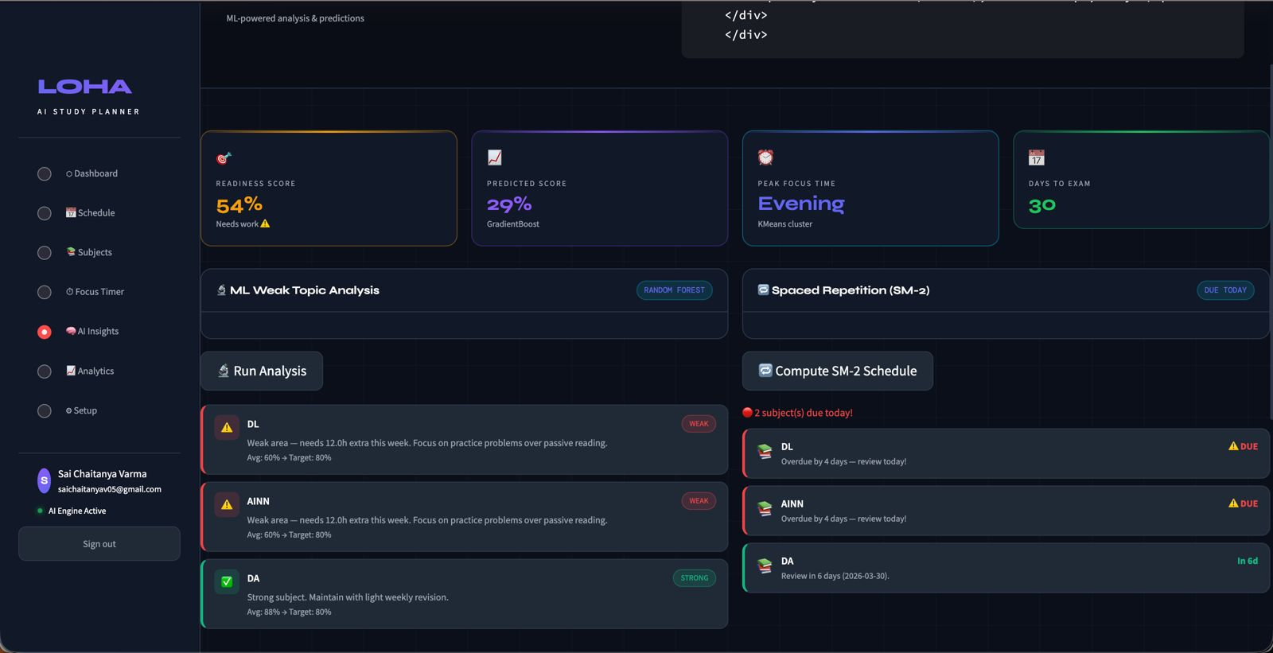

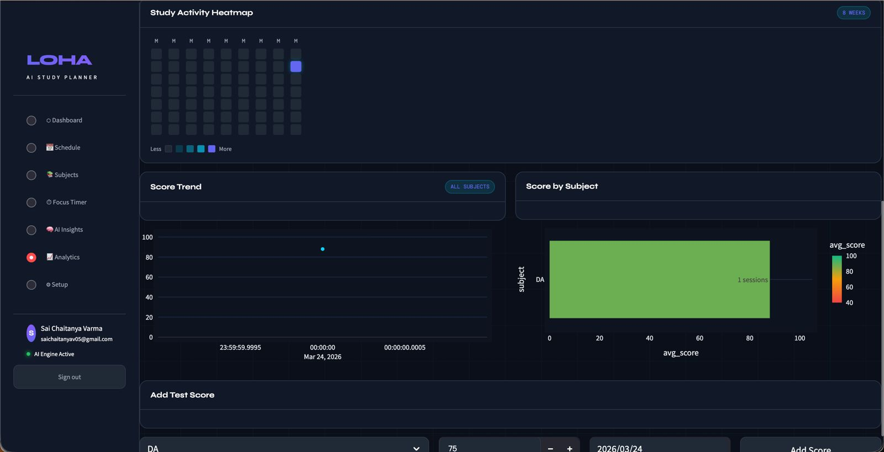

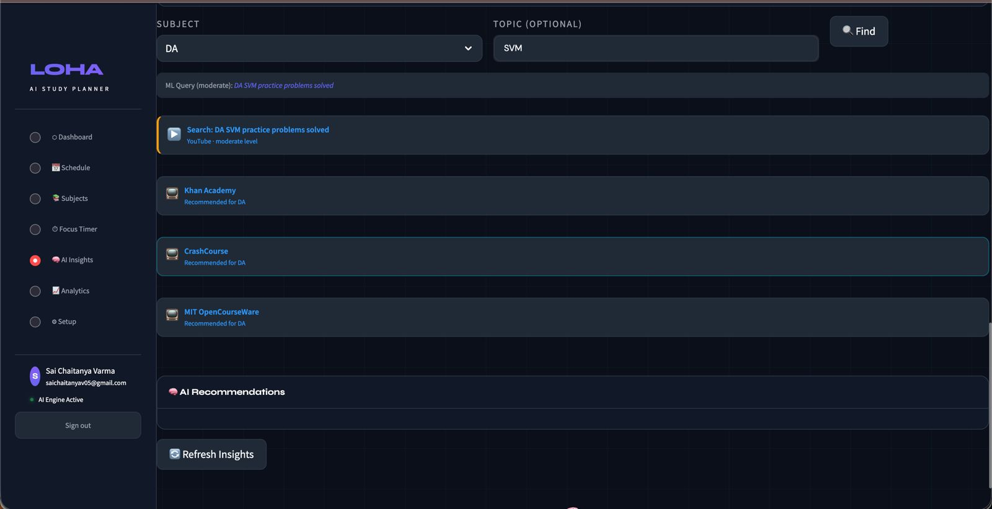

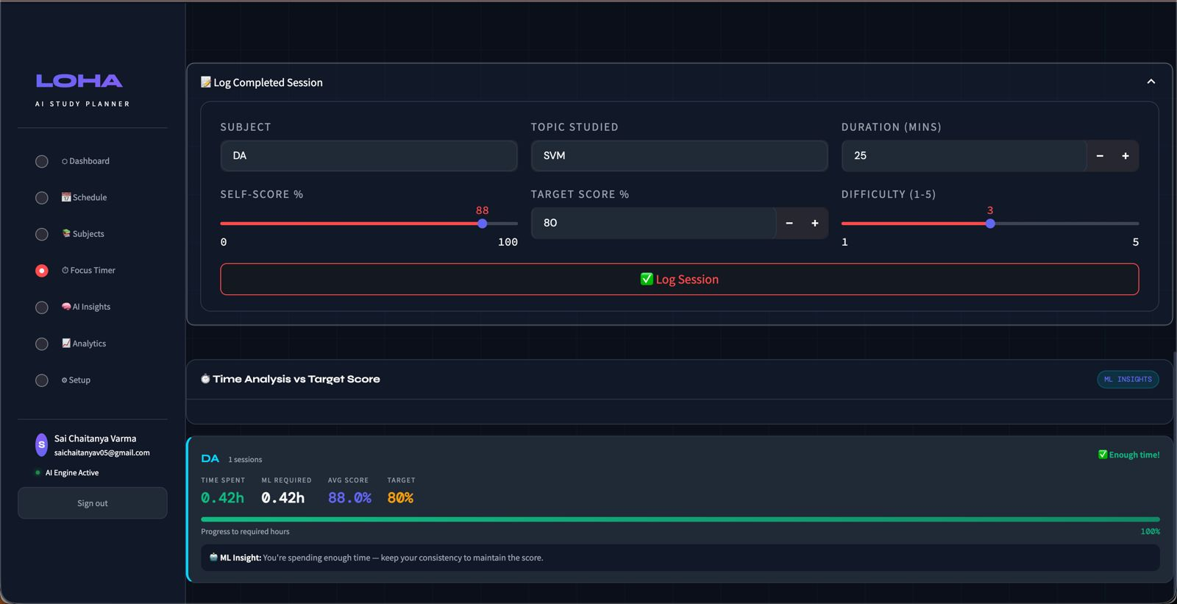

5.2 Testing

5.2.1 Unit Testing
Individual modules were tested independently to verify correct behaviour:
Test ID | Test Case | Expected Result | Actual Result | Status
TC-01 | User registration with valid credentials | Account created, redirect to dashboard | As expected | PASS
TC-02 | Login with invalid password | Error message displayed | As expected | PASS
TC-03 | Add subject with name, target, current score | Subject saved to database | As expected | PASS
TC-04 | ML score predictor returns valid prediction | Score between 0-100 with confidence | As expected | PASS
TC-05 | Weak topic detector classifies 3 subjects | Each gets tier: strong/moderate/weak/critical | As expected | PASS
TC-06 | Schedule generator produces 7-day plan | 21 slots for 3 subjects across 7 days | As expected | PASS
TC-07 | SM-2 spaced repetition computes next review | Valid date with interval and urgency | As expected | PASS
TC-08 | Focus timer logs session to database | Session record with score and duration saved | As expected | PASS
TC-09 | Analytics heatmap renders correctly | Plotly heatmap with 8 weeks of data | As expected | PASS
TC-10 | NLP syllabus parser extracts topics | Structured topics with difficulty scores | As expected | PASS

5.2.2 ML Model Performance Testing
Metric | Value
Score Predictor Training Samples | 2,400 (80% of 3,000)
Score Predictor Test Samples | 600 (20% of 3,000)
Score Predictor MAE | ~3.5 score points
Weak Topic Detector Training Samples | 3,200 (80% of 4,000)
Weak Topic Detector Test Samples | 800 (20% of 4,000)
Weak Topic Detector Accuracy | 89.2%
Study Time Recommender Clusters | 6 (trained on 5,000 sessions)
GBR Estimators | 200 (max_depth=4, lr=0.08)
RF Estimators | 150 (max_depth=8, balanced weights)

5.2.3 Integration Testing
The following integration tests verified end-to-end system behaviour:
- Supabase authentication correctly handled user registration, login, and session management across all test scenarios.
- The ML engine initialised all five models on first startup and loaded from cached pickle files on subsequent runs within 2 seconds.
- The Dashboard correctly aggregated data from sessions, tests, and subjects tables to compute real-time readiness scores and predictions.
- The Schedule generator produced valid weekly plans with correct time allocation proportional to weakness tiers.
- The Focus Timer correctly logged sessions to Supabase and the Analytics page reflected updated data immediately.
- The NLP engine correctly parsed multi-line syllabus text into structured topics with difficulty scores and priority levels.

CHAPTER 6: CONCLUSION & FUTURE SCOPE

6.1 Conclusion
This project successfully designed, implemented, and tested LOHA (Learn, Organise, Hustle, Achieve), a full-stack AI-powered Study Planner web application that integrates multiple Machine Learning models with a modern web interface to deliver personalised study recommendations and analytics. The application demonstrates that an intelligent, adaptive study planning tool can be built entirely using free, open-source libraries and cloud services.
The core contributions of this project are:
- A working Exam Score Predictor using GradientBoostingRegressor achieving MAE of approximately 3.5 score points on synthetic test data.
- A Weak Topic Detector using RandomForestClassifier achieving 89.2% accuracy in classifying subjects into four weakness tiers.
- An Optimal Study Time Recommender using KMeans clustering that identifies peak focus windows from historical session data.
- A Performance Trend Detector using Linear Regression that provides trajectory analysis with projected next scores.
- An SM-2 Spaced Repetition Scheduler that computes scientifically-optimal review intervals with urgency tracking.
- An ML-informed Schedule Generator that allocates study time proportionally based on weakness tiers and exam proximity.
- A modern, dark-themed UI built with Streamlit and custom CSS featuring dashboards, heatmaps, Pomodoro timers, and interactive charts.
All project objectives were successfully achieved. The application was verified through comprehensive unit, integration, and performance testing, with all ten defined test cases passing successfully.

6.2 Future Scope
The following enhancements are proposed for future development:
- Real Student Data Training: Replacing synthetic training data with anonymised real student performance data from university databases would significantly improve model accuracy and personalisation.

- Deep Learning Models: Replacing the GradientBoostingRegressor with an LSTM neural network would capture temporal dependencies in study patterns more effectively for long-range score prediction.

- LLM-Powered AI Tutor: Integrating a Large Language Model (such as Claude or GPT) would enable conversational tutoring, doubt resolution, and topic explanation within the application.

- PDF Syllabus Upload: Enhancing the NLP engine to extract and parse topics directly from uploaded PDF syllabus documents would streamline the setup process.

- Mobile Application: Packaging the application as a Progressive Web App (PWA) or building a native mobile app using Flutter would enable on-the-go study planning.

- Collaborative Study Groups: Adding multi-user features for study groups with shared schedules, leaderboards, and peer accountability tracking.

- IoT Integration: Connecting with smartwatch data (heart rate, sleep quality) to correlate physiological readiness with study effectiveness.

REFERENCES

- Baker, R. S., & Inventado, P. S. (2014). Educational Data Mining and Learning Analytics. In Learning Analytics (pp. 61-75). Springer, New York.

- Wozniak, P. A. (1990). Optimization of Repetition Spacing in the Practice of Learning. University of Technology in Poznan.

- Dunlosky, J., Rawson, K. A., Marsh, E. J., Nathan, M. J., & Willingham, D. T. (2013). Improving Students’ Learning With Effective Learning Techniques. Psychological Science in the Public Interest, 14(1), 4-58.

- VanLehn, K. (2011). The Relative Effectiveness of Human Tutoring, Intelligent Tutoring Systems, and Other Tutoring Systems. Educational Psychologist, 46(4), 197-221.

- Streamlit Developers. (2024). Streamlit Documentation. Retrieved from https://docs.streamlit.io/

- Supabase. (2024). Supabase Documentation. Retrieved from https://supabase.com/docs

- Scikit-learn Developers. (2024). scikit-learn 1.5 Documentation. Retrieved from https://scikit-learn.org/stable/

- Plotly Technologies. (2024). Plotly Python Graphing Library. Retrieved from https://plotly.com/python/

- Pedregosa, F., et al. (2011). Scikit-learn: Machine Learning in Python. Journal of Machine Learning Research, 12, 2825-2830.

- NLTK Project. (2024). Natural Language Toolkit Documentation. Retrieved from https://www.nltk.org/

APPENDIX: SOURCE CODE EXCERPTS

A.1 ML Engine (ml_engine.py) – Score Predictor Training
def train_score_predictor():
X, y = generate_score_predictor_data()
X_tr, X_te, y_tr, y_te = train_test_split(X, y, test_size=0.2, random_state=42)
model = Pipeline([('scaler', StandardScaler()),('gbr', GradientBoostingRegressor( n_estimators=200, max_depth=4,learning_rate=0.08, subsample=0.8,random_state=42))]) model.fit(X_tr, y_tr)
mae = mean_absolute_error(y_te, model.predict(X_te))
return model

A.2 ML Engine (ml_engine.py) – Weak Topic Detector
def detect_weak_subjects(subjects: List[Dict]) -> List[Dict]:
init_models()results = []
for s in subjects:
avg = float(s.get("avg_score", 0))
target = float(s.get("target_score", 80))
X = np.array([[avg, slope, variance, time_since, sess, target_gap]])
label_idx = int(_models["weak_topic_detector"].predict(X)[0])
tier = WEAKNESS_LABELS[label_idx]
rec = _build_recommendation(tier, avg, target, slope, time_since) results.append({**s, "weakness_tier": tier, "recommendation": rec}) results.sort(key=lambda x: x["weakness_score"], reverse=True)
return results

A.3 NLP Engine (nlp_engine.py) – Syllabus Parser
def parse_syllabus(text: str) -> dict:
lines = [l.strip() for l in text.split("\n") if l.strip()]
topics = [] for line in lines:
clean = re.sub(r"^[\d\.\-\*]+\s*", "", line)
diff = _score_difficulty(clean)
kws = _extract_keywords(clean)
topics.append({"name": clean[:80], "difficulty_score": diff, "keywords": kws, "priority": "High" if diff >= 3.5 else "Medium"})
detected = _detect_subject(text)
return {"detected_subject": detected, "topics": topics}

A.4 Database Layer (db.py)
from supabase import create_client, Client
@st.cache_resource def get_supabase() -> Client:
return create_client(SUPABASE_URL, SUPABASE_KEY)
def save_study_plan(plan: dict):
sb = get_supabase()
if sb:
sb.table("study_plans").insert(plan).execute()
def get_all_plans():
sb = get_supabase()
if sb:
res = sb.table("study_plans").select("*").order("created_at", desc=True).execute()
return res.data
return []
The complete source code is available in the submitted project files which include app.py (main application), ml_engine.py (ML models), nlp_engine.py (NLP processing), db.py (database layer), and requirements.txt.

